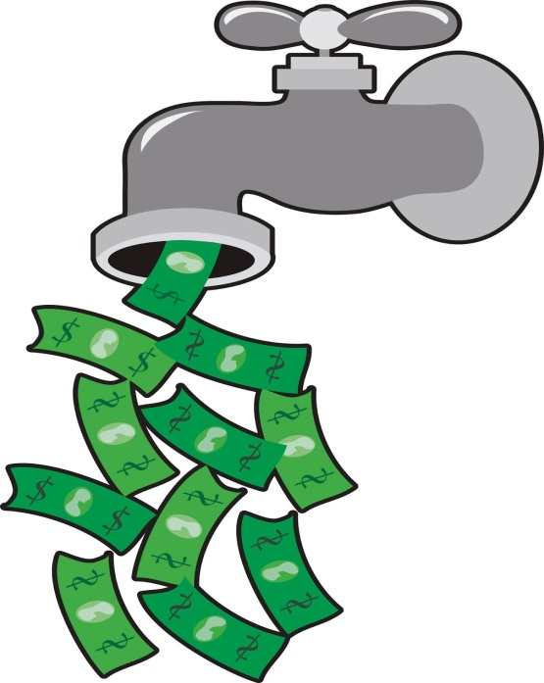
Does you water bill seem HIGH? Don’t blame your water utility company!

Dripping Faucets and other leaks waste water and energy!

Water waste at 40 pounds pressure:
- 1/32 leak wastes 170 gallons in 24 hours
- 1/16 leak wastes 970 gallons in 24 hours
- 1/8 leak wastes 3,600 gallons in 24 hours

Water Costs Money,
Don’t Waste it!

